Professor: Chuck Bland

EE 375 Section 02

12:10 - 3:00 PM Tuesday

Lab #8

Single and Double Stub Tuners

Written By:

John Gharib

Aria Amini

Austin Ma

June 1, 2021

# 1. Single Stub Matching

1. Worked Out Smith Chart

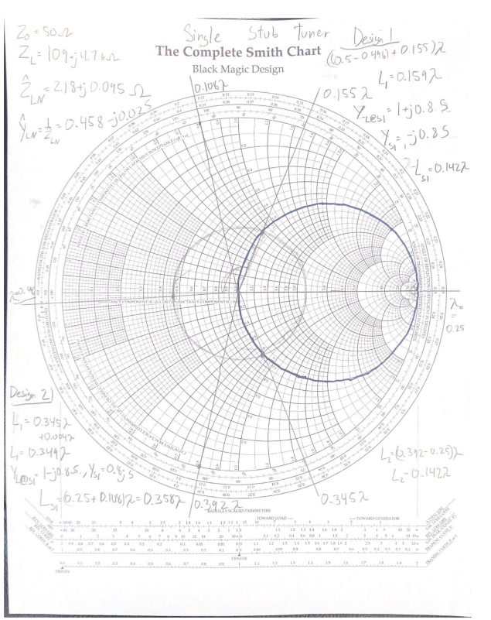

Figure 1: Smith chart for Single Stub Tuner.

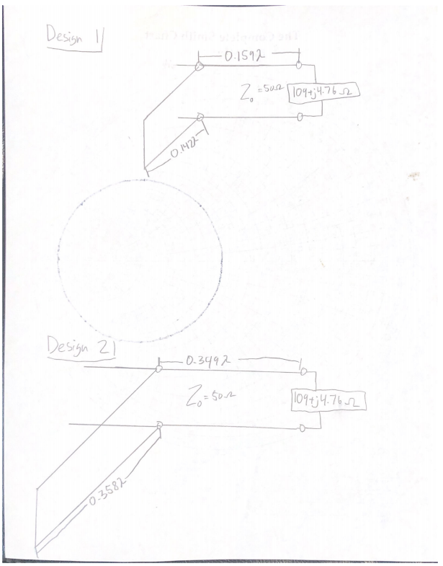

Figure 2: Design 1 and 2 for the Single Stub Tuner.

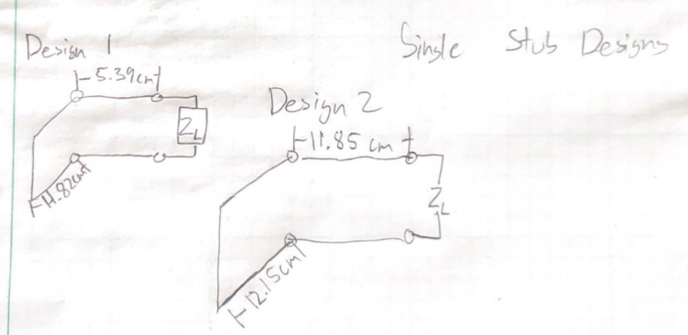

Figure 3: Design 1 and 2 for the Single Stub Tuner in cm.

1. Analytical Spreadsheet

| Output Parameters | |  |  |  |  | Complex Gamma |  |  |
| --- | --- | --- | --- | --- | --- | --- | --- | --- |
| Gamma | 0.372 | 0.019 | 0.3721 | 2.90 |  | 0.372+0.0191j |  |  |
|  |  |  |  |  |  | **Length** | | |
|  | **A** | **A'** | **B** | **B'** | **ƛ** | **Meters** | **Feet** | **Inches** |
| Distance from Load | 0.1594 | 0.1594 | 0.3487 | 0.3487 | 0.1594 | 0.053 | 0.172 | 2.1 |
| Length of Stub | 0.1424 | 0.1424 | -0.14244 | 0.3576 | 0.1424 | 0.047 | 0.154 | 1.8 |

1. Online Tool

Figure 4: Javascript design for single stub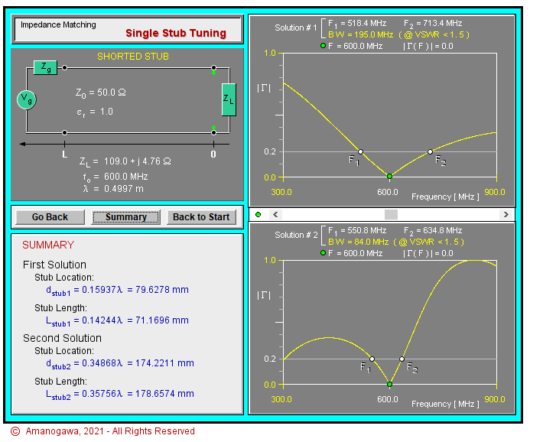

1. Data, plot, and calculation on procedure 3

Unadjusted data:

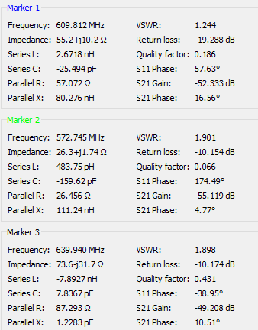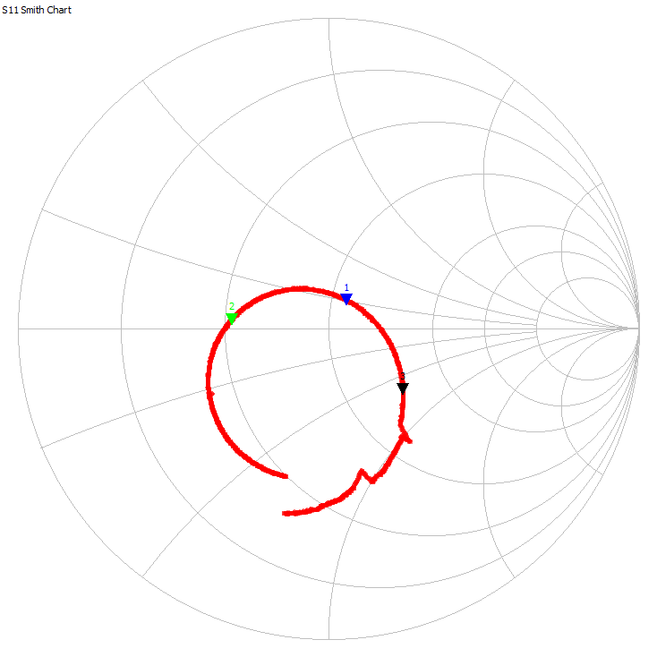

Figure 5 (left): Unadjusted single stub data

Figure 6 (right): Unadjusted single stub Smith Chart

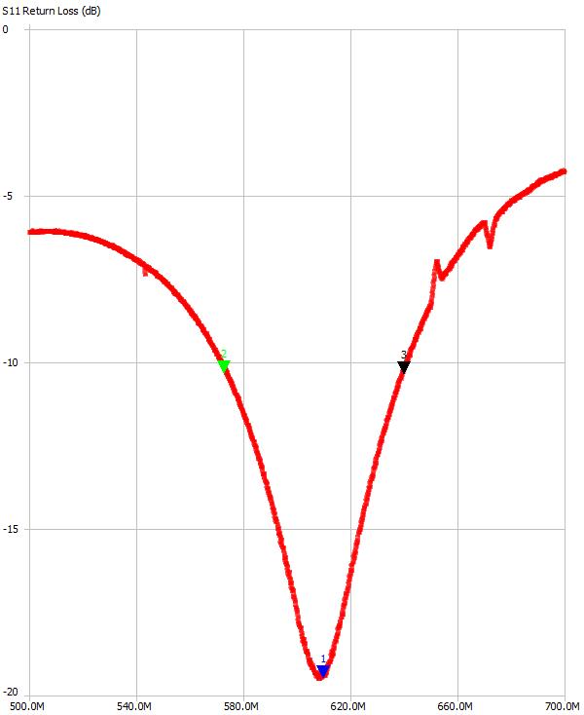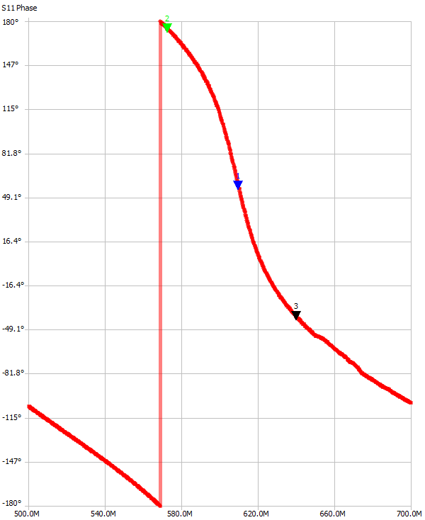

Figure 7 (left): Unadjusted single stub S11 magnitude

Figure 8 (right): Unadjusted single stub S11 phase

Tuned data: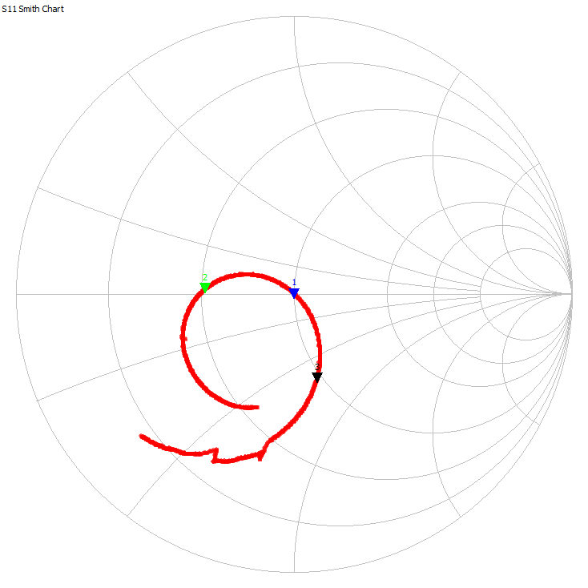

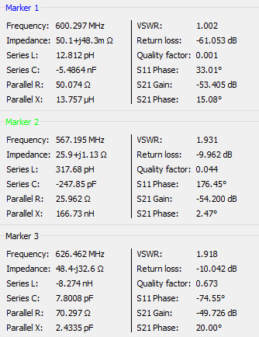

Figure 9 (left): Tuned single stub data

Figure 10 (right): Tuned single stub Smith Chart

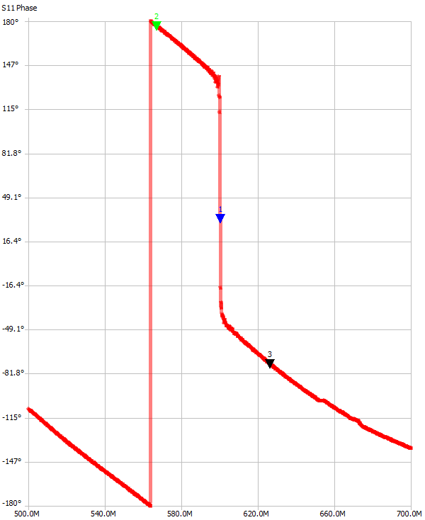

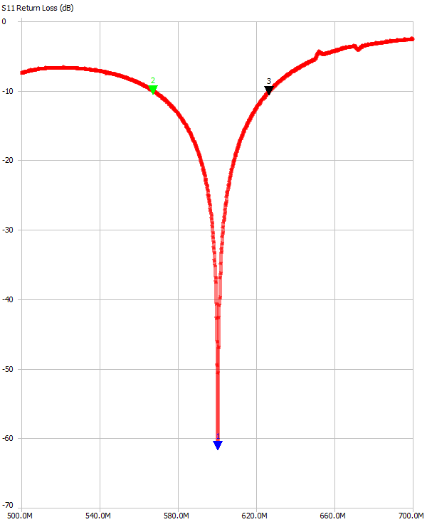

Figure 11 (left): Tuned single stub S11 magnitude

Figure 12 (right): Tuned single stub S11 phase

# 2. Double Stub Matching

1. Worked Out Smith Chart

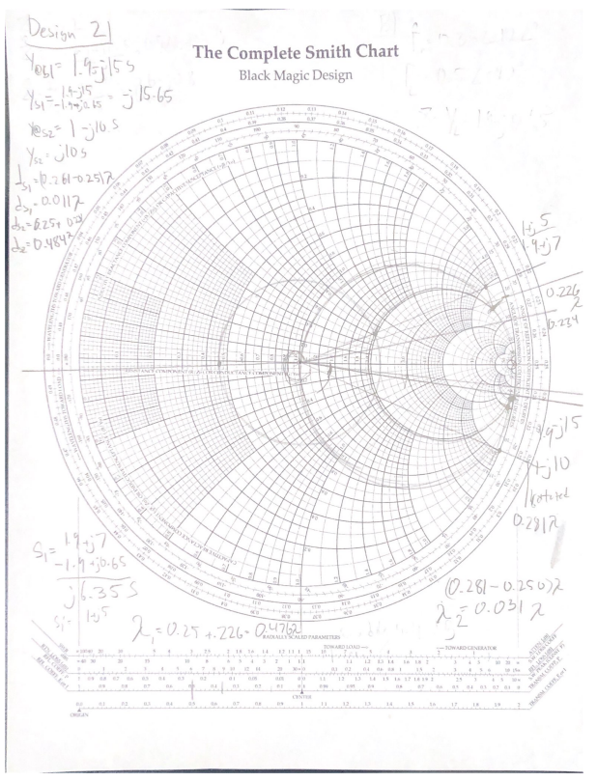

Figure 13: Worked out Smith chart of Double Stub Tuning.

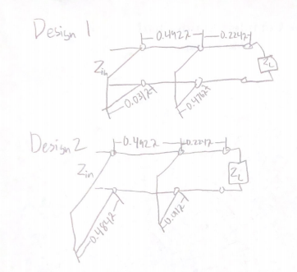

Figure 14: Depiction of both designs, with distances in respect to λ.

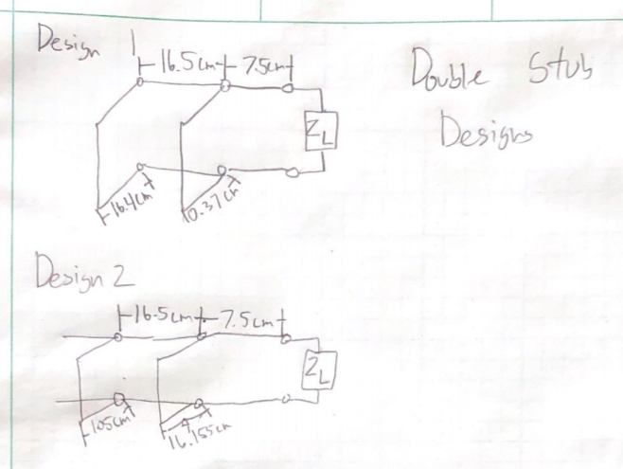

Figure 15: Depiction of both designs, with distances in cm. (Lengths for design 1 and 2 are switched).

1. Online Tool

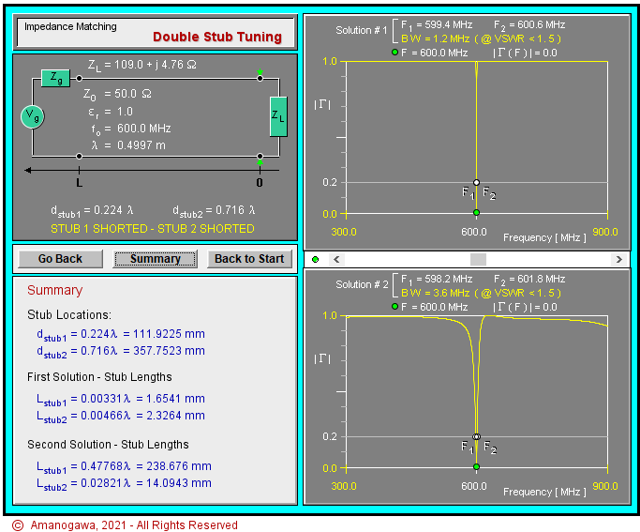

Figure 16: Javascript design for double stub

1. Data, plot, and calculation on procedure 4

Unadjusted data:

Figure 17 (left): Unadjusted double stub data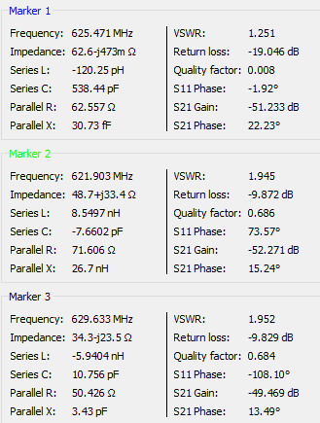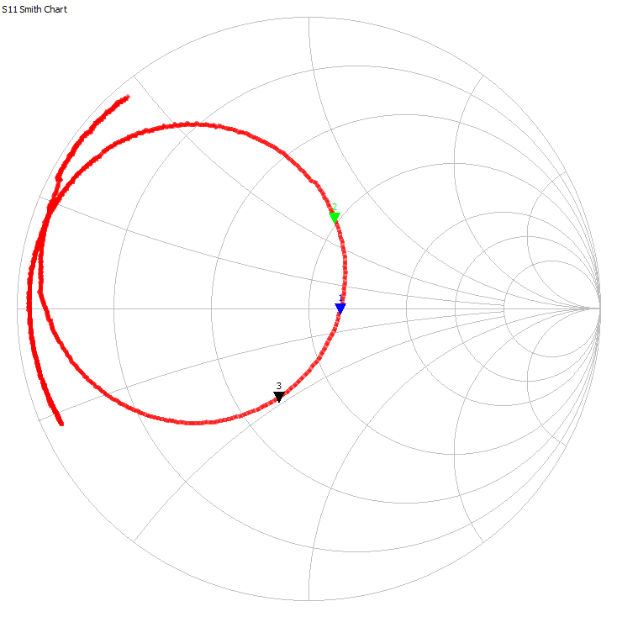

Figure 18 (right): Unadjusted double stub Smith Chart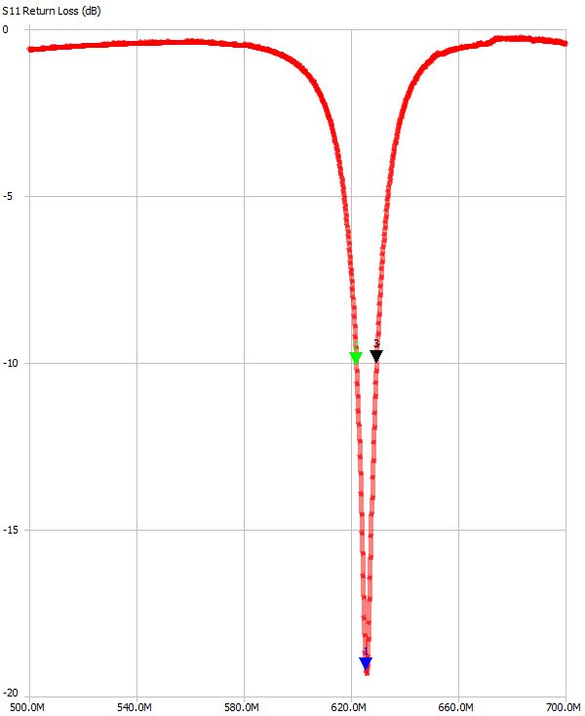

Figure 19 (left): Unadjusted single double S11 magnitude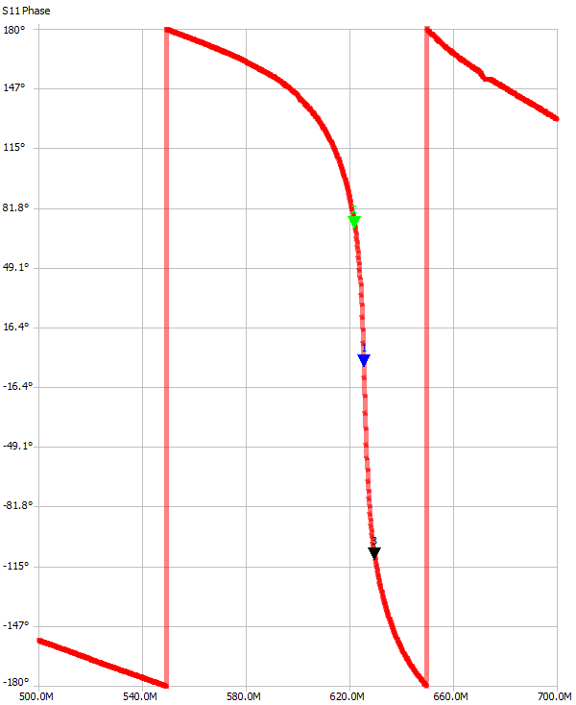

Figure 20 (right): Unadjusted single double S11 phase

Tuned data:

Figure 21 (left): Tuned double stub data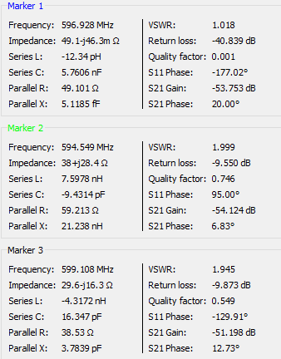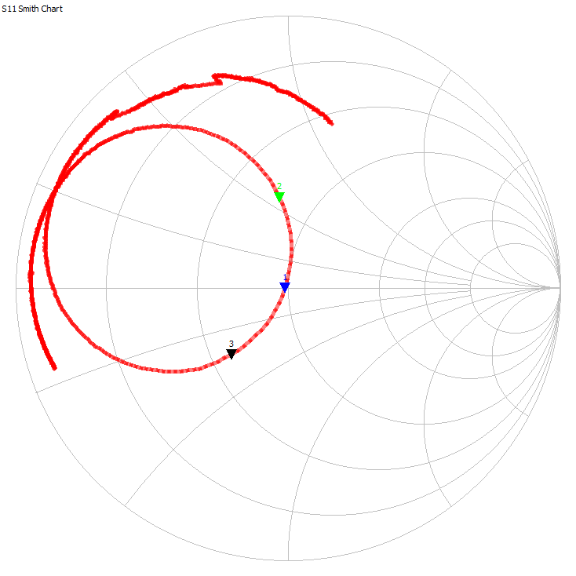

Figure 22 (right): Tuned double stub Smith Chart

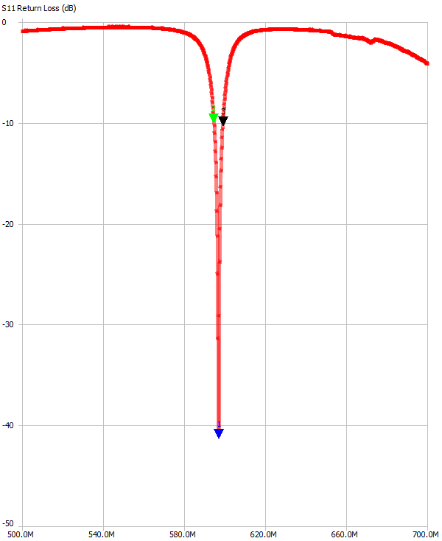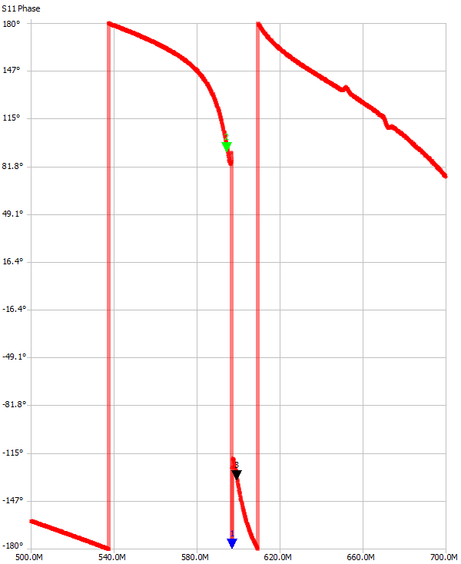

Figure 23 (left): Tuned single double S11 magnitude

Figure 24 (right): Tuned single double S11 phase

# CONCLUSIONS:

|  | **Single stub** | | **Double stub** | |
| --- | --- | --- | --- | --- |
|  | **Original** | **Tuned** | **Original** | **Tuned** |
| Input VSWR | 1.244 | 1.002 | 1.251 | 1.018 |
| -10dB percent bandwidth | 11% | 9.88% | 1.23% | 0.77% |
| Stub length (Δλ) | 0.142 | .14244 (1st soln)  .35756 (2nd soln) | 0.00331 & 0.00466 | .3142 & .1931 (1st soln)  .141 & .247 (2nd soln) |
| Transmission line length (Δλ) | 0.159 | .15937 (1st soln)  .34868 (2nd soln) | 0.224 & 0.716 | .1587 & .3765 |

Aria Amini: This lab compared the designs of single stub and double stub tuners to match a load impedance of 109+4.76j ohms at 600 MHz using a 50 ohm transmission line. The single stub matching circuit was designed using a Smith Chart, Spreadsheet tool, and online Java simulation software which all produced similar circuit designs using 0.159λ transmission line length and 0.142λ stub length. This original design produced a -10dB percent bandwidth of 11%, but was further tuned in the lab to have a percent bandwidth of 9.88%. The double stub matching circuit was also designed using the Smith Chart and online Java tool which both produced similar circuit designs. This original design produced a -10dB percent bandwidth of 1.23% but was improved to 0.77%. This lab showed that there are multiple different transmission line designs and lengths that can be used to match a load, but certain designs may be preferred depending on what the design requirements are. Single stub designs use less coax and are likely cheaper to implement, but double stub designs are better at matching the load and produce better filters overall with lower achievable -10dB percent bandwidth.

John Gharib: In this experiment, , we saw the before and after of how a single and double stub tuner affects a load. The tuners we used in class were designed using a smith chart, and verified using a Java based computer program. The single stub tuner used less coax overall, but required placement at a very specific location to work, which is not possible for every application, which is a huge disadvantage. However, the double stub tuner can be seen as an “all in one package”that is inserted into the transmission line, and is more powerful than the single stub tuner. It was also seen that the double stub tuner had a significantly narrower bandwidth, which made it a much higher quality filter.

Austin Ma:

The double stub after being tuned became a significantly better notch filter, despite already being a big upgrade from the single stub which makes a visible “u” to “v” shape after the tuning. Using the Java Applet, we were able to check our paper calcs and parameters in our attempts to escape the forbidden zone we often entered by looking at the distances incorrectly between the stubs. Our biggest error was not considering that we had to add the distance between stub 1 and 2 to the distance between the load plane and stub 1 to consider the electrical distance towards the load and the generator. It required a lot of circles, rotating, and compass usage to get this done!